14/12/2020

|  |
| --- |
| eM-Age Calculator v. 1.1 (Dec 2020) | Carlos Pérez Garrido |

|  |  |
| --- | --- |
| User Manual | eM-Age calculator v1.1 |

Index

1. Introduction 2

1.1 Getting Started 2

2. Program structure 3

2.1 Main characteristics 3

2.2 **“Data”** Tab 4

2.3 **“Dosimetry (External-Internal-Cosmic)”** Tab 7

**2.3.1** **External dose** 7

**2.3.2** **Internal dose** 8

**2.3.3** **Cosmic dose** 9

2.4 **“Dosimetry (correction factors)”** tab 10

**2.4.1** **Conversion factors** 10

**2.4.2** **Water content parameters** 10

**2.4.3** **Alpha dosimetry** 12

**2.4.4** **Beta dosimetry** 12

**2.4.5** **Gamma Dosimetry** 13

2.4.6 Graphs 13

2.5 **“Results & Graphs”** Tab 13

**2.5.1** **Selected model for Age Calculation** 15

2.5.2 Graphs 15

2.6 **“Summary”** tab 16

3. Save Results 16

4. References 16

1. Introduction

eM-Age is a program based on the Microsoft Visual Basic for Application (VBA) designed to perform automated calculation of the environmental radiation dose rate (for luminescence dating and other trapped charge dating application) and final luminescence ages.

The program has been designed to be user-friendly aspect used in a Windows environment equipped with Microsoft Excel 2007 or later.

A repository of the program can be found at <https://github.com/yomismovk/eM-Age-program>

* 1. Getting Started

For clearer explanations of the different parameters, the following annotations are used:

Excel worksheets 🡪 Report

Button 🡪 Re-Calculate

Tab 🡪 **Data**

Frame (data group) 🡪 **External dose**

Label (data entry) 🡪 *Dose rate reader*

Label (info only) 🡪 *Selected data*

Message 🡪 Loading Data. Please wait

Round selection 🡪 Type of analysis

Checkbox 🡪 *User Alpha dose rate*

To run eM-Age, the use of macros must be enabled in Excel. Click “Enable content”.

To start eM-Age click on the Run eM-Age calculator v1.1 button (Fig. 1).

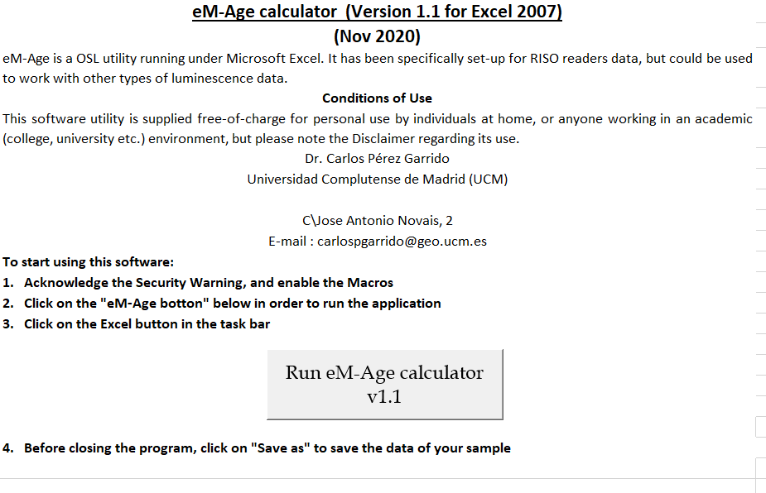

Figure 1

The program automatically minimizes the Microsoft Excel window and highlights the Excel icon in the task bar. Press the Excel button to show the main program window (Fig. 2).

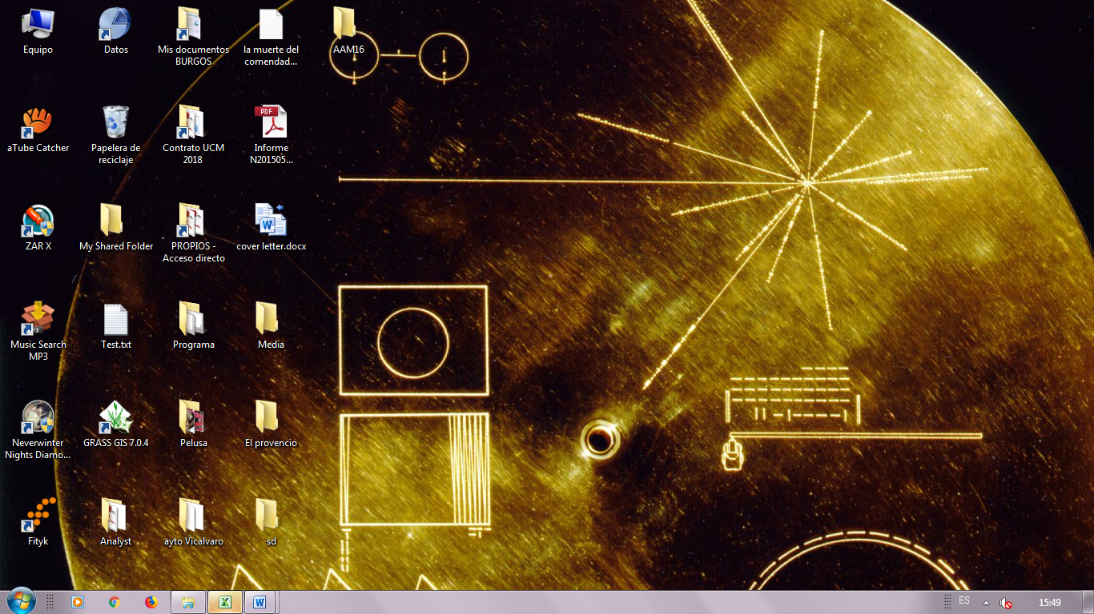

Figure 2

The program automatically loads the previous data saved (which can take several seconds) and the caption “Loading Data. Please wait” will be shown. Then, a screen similar to Fig. 3 is shown.

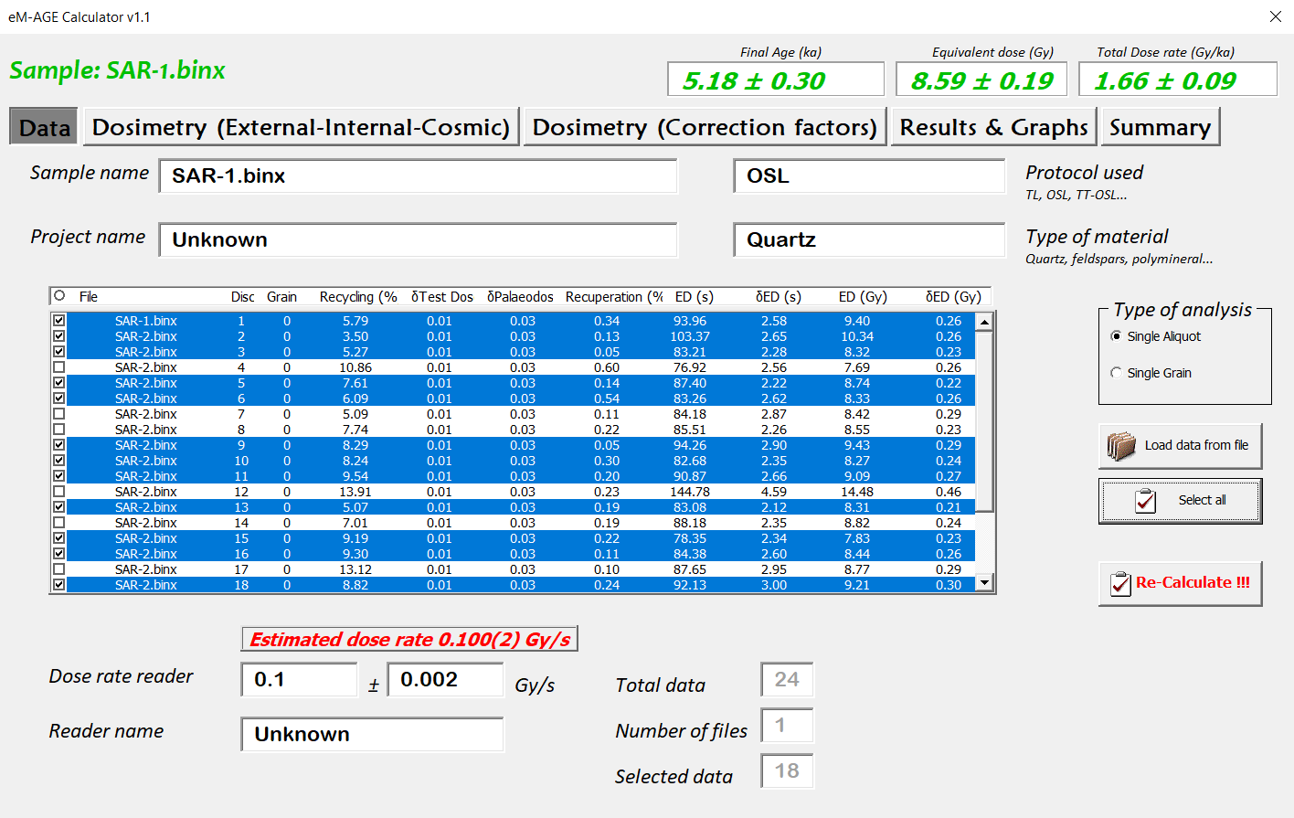

Figure 3

1. Program structure

The final luminescence age is calculated by division of the equivalent dose (in Gy) by the estimated dose rate (in Gy/ka) based on the following expression:

Age (ka) = De (Gy) / Dr (Gy/ka)

where the De is the equivalent dose accumulated in Gray (Gy); the Dr is the dose rate that comes from exposure to ionizing radiation from α, β and γ particles in the grain (in Gy per kiloannum, Gy/ka), surrounding sediments, and from cosmic rays (Aitken, 1998).

* 1. Main characteristics

The program screen is divided into several parts. At the top of the screen (Fig. 4, in green), the program shows the updated sample name, the calculated final age (ka), the equivalent dose used (Gy) and the total dose rate (Gy/ka).



Figure 4

Below this part, there are five tabs to input the different parameters and data required for analysis (Fig. 5), **Data**, **Dosimetry (External-Internal-Cosmic)**, **Dosimetry (Correction factors)**, **Results & Graphs** and **Summary**.

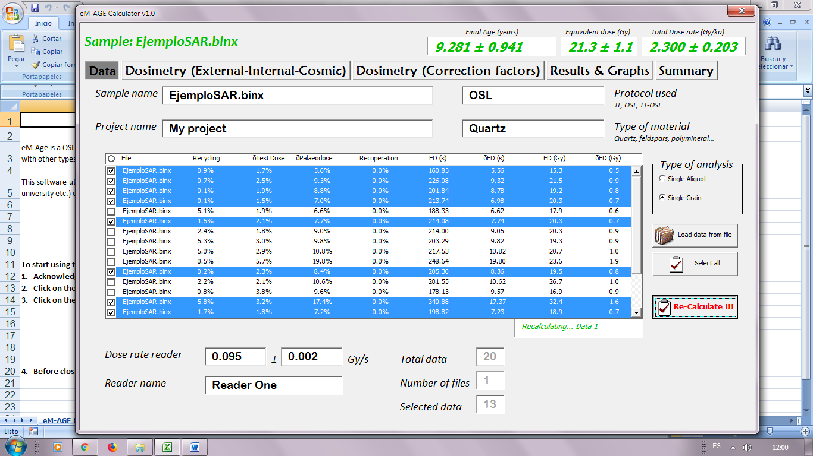

Figure 5

* 1. **“Data”** Tab

This page allows users to input significant information for a sample, such as sample name, project, type of material, protocol used, etc.

These data are used for subsequent calculations, such as applying statistical age models.



Figure 6

Label descriptions

*Sample name* (text label, optional)

Name of the user’s sample or name of the sample loaded (see below button Load) from a file. Although this is an optional input, input is suggested since it will appear in the external files created by the program (Graphs and reports, see section 3. Save Results).

*Project name* (text label, optional)

Name of the Project to organize your data.

*Protocol used* (text label, optional)

Type of protocol used, for example, OSL, TT-OSL, TL, etc…

*Type of material* (optional)

Type of material used, for example, quartz, feldspars, other minerals…

**Type of analysis**

There are two options to choose, Single Grain or Single Aliquot. This label is only for organization of the data and hasn’t implication in the calculus.

*Dose rate reader* (optional)

This label is for the source strength of the reader used and is used to convert the measured dose in seconds to dose in Grays (Gy). When a .ANR file is loaded, the program search information about the dose rate of the reader used into the file. If there is not data, the label shows “N.D.” (no data) and the program assume a dose rate of 0.100 ± 0.002 Gy/s. Also, a warning message saying “Estimated dose rate 0.100(2) Gy/s” appears above this label (Fig. 7).

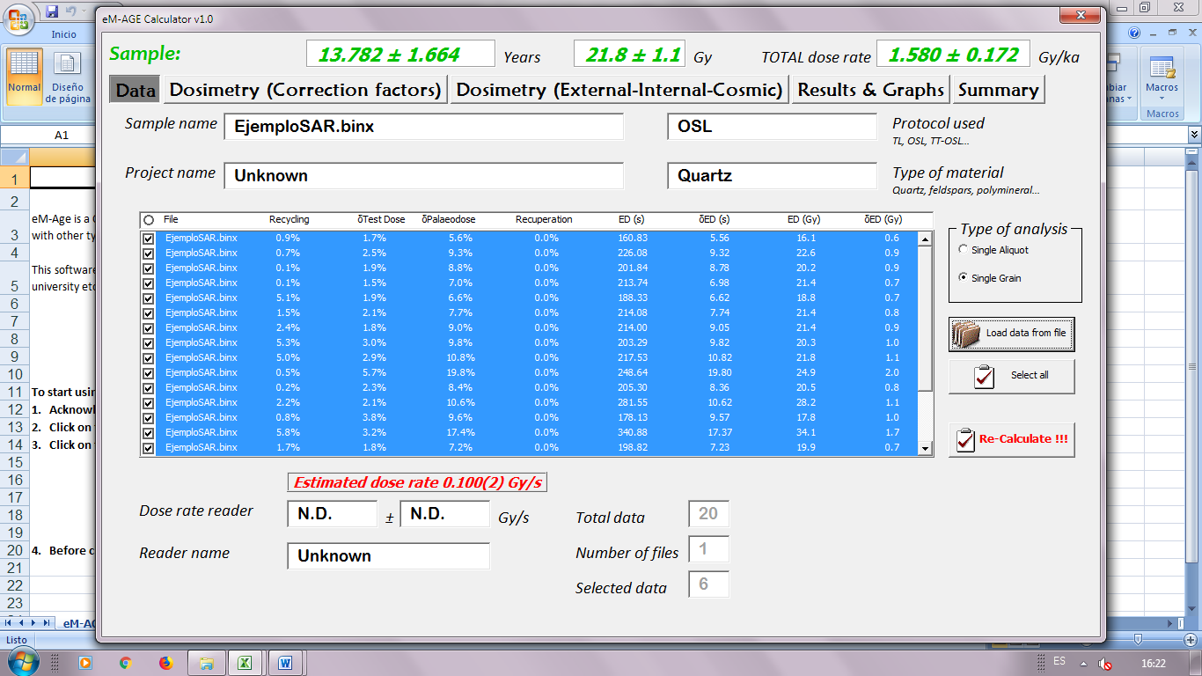

Figure 7

*Reader name* (text label, optional)

Name assigned to the reader of your lab.

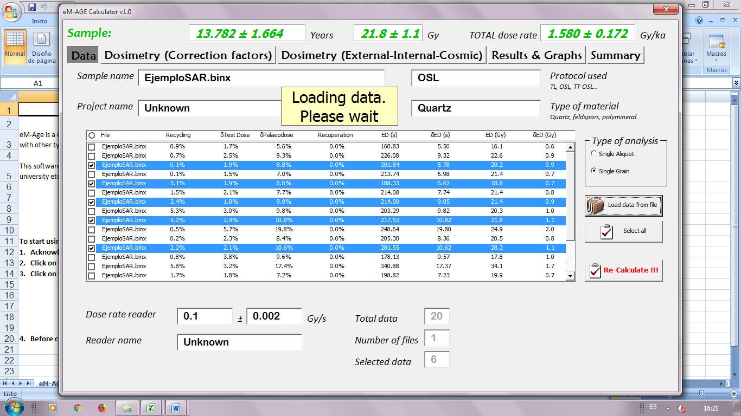

Load data from file

This button allows the import of equivalent dose values and other parameters from“Analyst”(.ANR file from any version of Analyst). It is possible to load more than one file at the same time selecting the files within the standard Windows file selection dialogue box. These data are uploaded into the table in the middle of the screen (Fig. 8) showing different information and parameters about the file loaded.

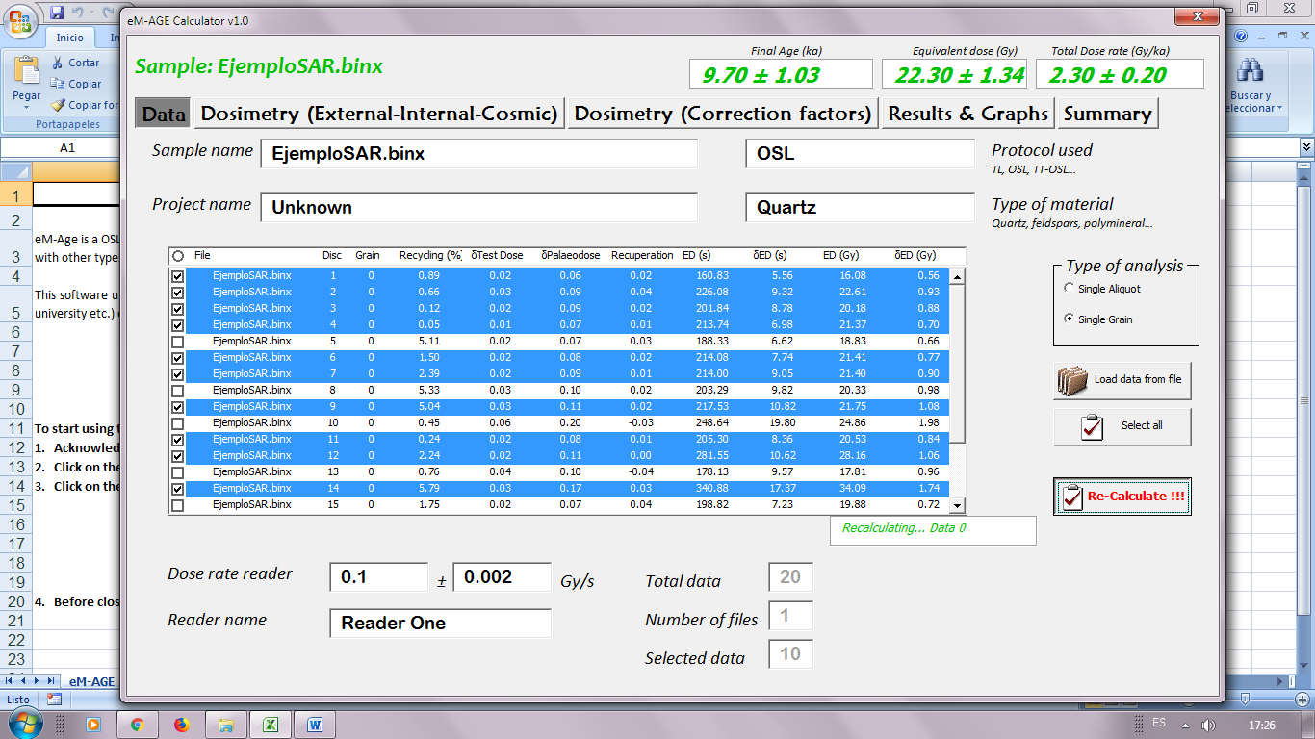

Figure 8

* File: Name of the file loaded.
* Disc: Position of the disc measured.
* Grain: Position of the grain measured.
* Recycling (%): Percentage of recycling ratio*.
* δ Test Dose (%): Percentage uncertainty in the test dose*.
* δ Palaeodose (%): Percentage uncertainty in the palaeodose*.
* Recuperation (%): Percentage of recuperation in the analysis performed with Analyst (% of Natural or Largest R)*.
* ED (s): Equivalent dose in seconds.
* δ ED (s): Uncertainty of equivalent dose in seconds.
* ED (Gy): Equivalent dose in Grays.
* δ ED (Gy): Uncertainty of equivalent dose in Grays.

*For a more detailed explanation of these parameters, see Analyst manual v.4.57 (Duller, 2018; p. 49).

All this information is useful for the user to decide which data will be treated by the program. Only the data highlighted (in blue) will be taken into account for the calculation. To choose or remove a data from the table, just click on the data. Every time the user changes the data table (select or unselect data or a new data file is loaded) it is necessary to press the Re-Calculate!!! button (see below). If not, the results shown will correspond to the previously selected data.



Select all

Select all the data showed in the table. To perform the calculations it is necessary to press the Re-Calculate!!! button.



Re-Calculate!!!

This button makes the pertinent calculations (equivalent dose calculation, final age and associated uncertainties) taking into account the selected data from the table. At the end of the process a pop-up message informs that the process of calculus is done (Fig. 9). If too many data are selected (or loaded from a file) this process could take several minutes, depending on the speed of your CPU.

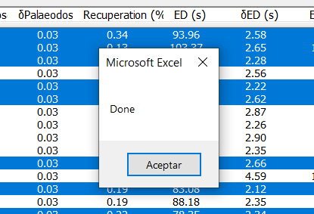

Figure 9

There are tags that summarise the selection and the loaded data (Fig. 10).



Figure 10

*Total data*

Total number of data loaded from the file(s).

*Number of files*

Number of files loaded (.ANR files).

*Selected data*

Selected data from the table that will be used for the calculation. This label will change once the Re-Calculate!!! button is pressed.

* 1. **“Dosimetry (External-Internal-Cosmic)”** Tab

The parameters in this tab are organized in three different groups **External dose**, **Internal dose** and **Cosmic dose** as is showed in Fig. 11.

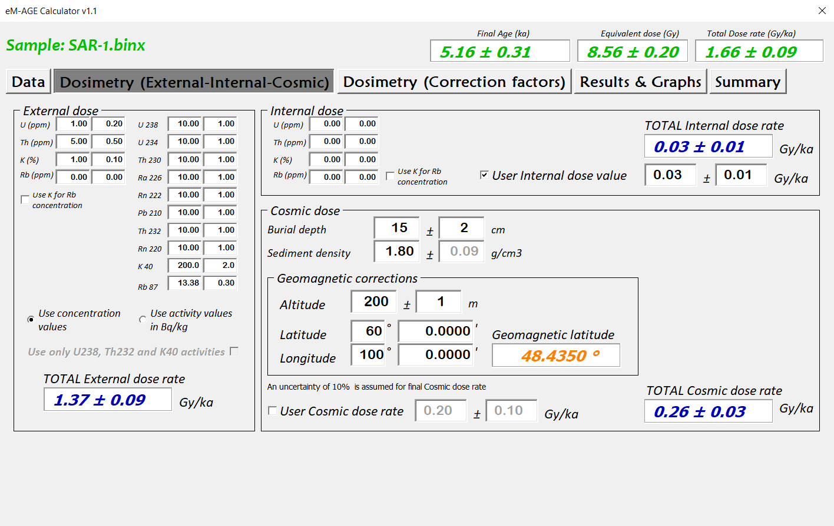

Figure 11

At any moment, the total external, internal and cosmic dose rate values are showed in blue. The dose rate is calculated by combining the attenuated α, β, γ and cosmic dose rates (from internal and external sources). For total dose rates, the values are combined and uncertainties are propagated in quadrature.

The dose rate is often calculated from the concentrations of radionuclides within 30 cm radius of the sampling site based on the assumptions of an infinite matrix and secular equilibrium in the U and Th series (Aiken, 1998; Guérin *et al*., 2012).

* + 1. **External dose**

The user can introduce the values of radionuclei concentration in the surrounding sediments (assuming infinite matrix and secular equilibrium in the U and Th series) as shown in Fig. 12. Dose rates are calculated from radionuclide concentrations or activities and the chosen conversion factors (see **“Dosimetry (Correction factors)”** tab).

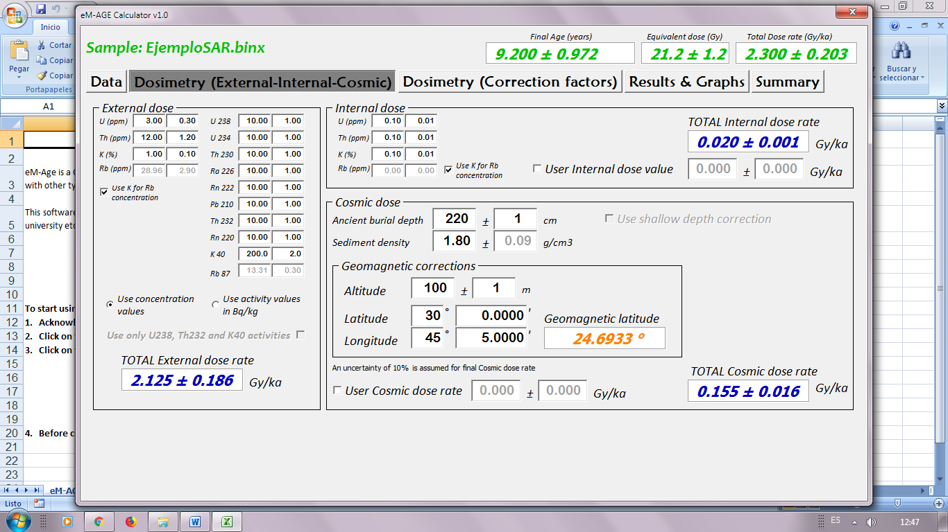

Figure 12

The program gives two options to introduce these values:

Use concentration values

Allows the input of concentrations of U, Th and K (Rb optional).

Use activity values in Bq/kg

Allows the input of the activities of the different radionuclei that compound the U and Th decay series, as well as the K (and Rb, optional) activities. There is also the option to take into account only the 238U and 232Th activities by selecting the *“Use only U238, Th232 and K40 activities”* checkbox (Fig. 13).

.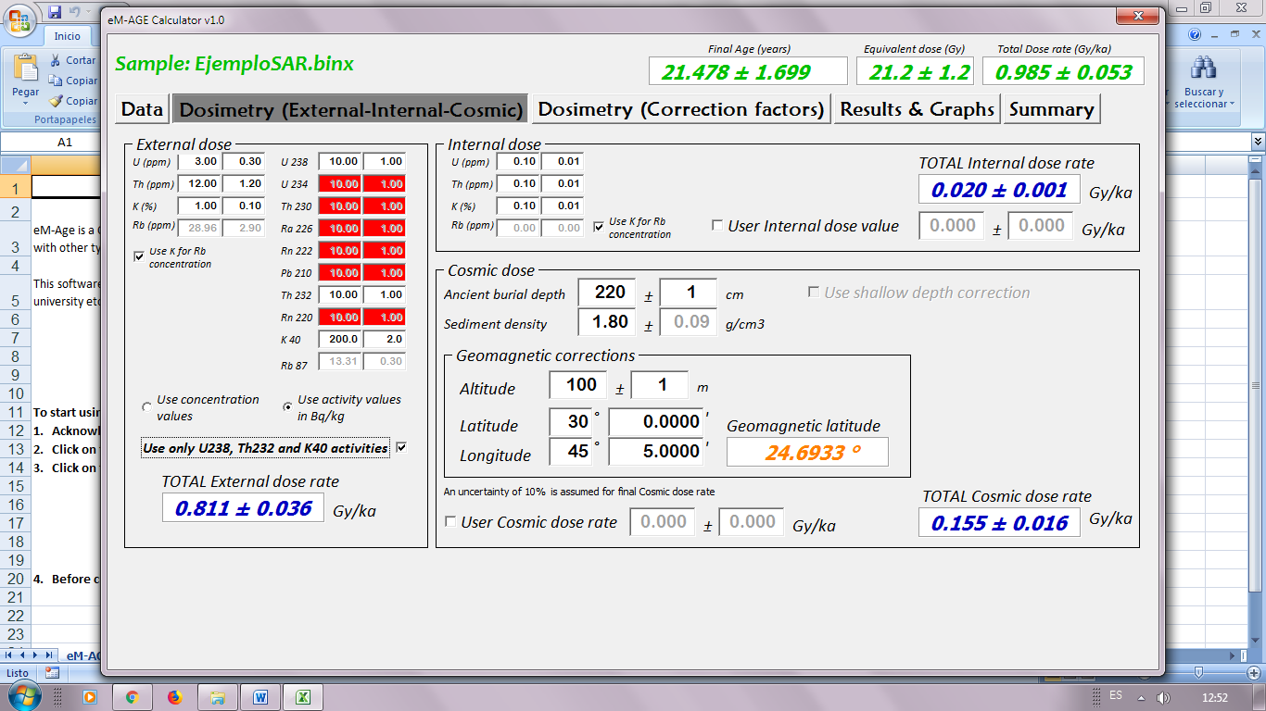

Figure 13

If *“Use K for Rb concentration”* is selected, the program calculates the Rb concentration from the K concentration using the formula proposed by Mejdahl (1987), where Rb (ppm) is equal to 9.17 · 38.13 K (%).

If radionuclide concentrations (U, Th, K and Rb) or activities of the U, Th and K series have been provided, the dose rate arising from each radionuclide is attenuated individually, before being summed to produce the attenuated alpha dose or beta dose (Durcan *et al*., 2015).

* + 1. **Internal dose**

As well as the **External dose**, the user can input the values of U, Th and K (Rb optional) that contribute to the internal dose of the grains. Dose rates are calculated from radionuclide concentrations and multiplied by the chosen conversion factors (see **“Dosimetry (Correction factors)”** tab). The values input will be corrected by the alpha attenuation factor (see **“Dosimetry (Correction Factors)”** tab). Also, if the internal dose value is known (sum of alpha and beta contribution), the user can input it by selecting the *“User Internal dose value”* checkbox (Fig. 14).

If *“Use K for Rb concentration”* is selected, the program calculates the Rb concentration from the K concentration using the formula proposed by Mejdahl (1987), where Rb (ppm) is equal to 9.17 · 38.13 K (%).



Figure 14

* + 1. **Cosmic dose**

This frame (Fig. 15) allows the user to input the parameters to calculate the cosmic dose rate. The cosmic dose calculation procedure, detailed in Prescott and Hutton (1994; p. 500), is used.



Figure 15

For the calculation procedure, a number of parameters are required:

*Sediment density*

Mean value of the sediment density. A default value of of 1.80 g/cm3 is input and can be amended.

*Altitude*

Elevation in meters of the sample with respect to the mean average sea level (in m.a.s.l.). This parameter, along with sample coordinates, is used to correct the cosmic dose rate for the sample-specific geomagnetic latitude and altitude.

*Sample coordinates*

Sample Latitude and Longitude in degrees. Also, the geomagnetic latitude derived from the data is showed in orange. North and East are positive values, while South and West are negative values.

For cosmic dose rates, an uncertainty of ± 10% is assumed due to possible fluctuations in cosmic dose rates over longer-term time-scales (Prescott and Hutton, 1994).

The user can introduce a cosmic dose rate if it is known selecting the *“User cosmic dose rate”* checkbox.

* 1. **“Dosimetry (correction factors)”** tab

In this tab are all the available attenuation parameters affecting the infinite matrix doses introduced in the **Dosimetry (External-Internal-Cosmic)** tab or by the user. A set of conversion factors are used to calculate the infinite matrix α, β and γ dose rates derived from the radionuclide information. The attenuation factors are separated in different sections (Fig. 16).

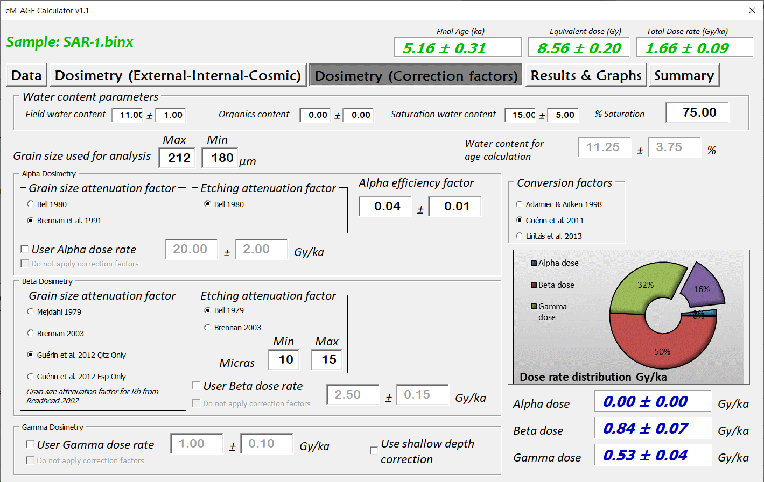

Figure 16

* + 1. **Conversion factors**

eM-Age offers the possibility to choose between frequently used dose rate conversion factors i.e. Adamiec and Aitken (1998), Guerin *et al*. (2011) or Liritzis *et al*. (2013) (Fig. 17). The uncertainties are propagated in quadrature when calculating the dose rate from each of the radionuclides. Due to the absence of calculated uncertainties in the data published by Guerin *et al*. (2011) and Adamiec and Aitken (1998), proportional uncertainties derived from Liritzis *et al*. (2013) are used in these datasets.

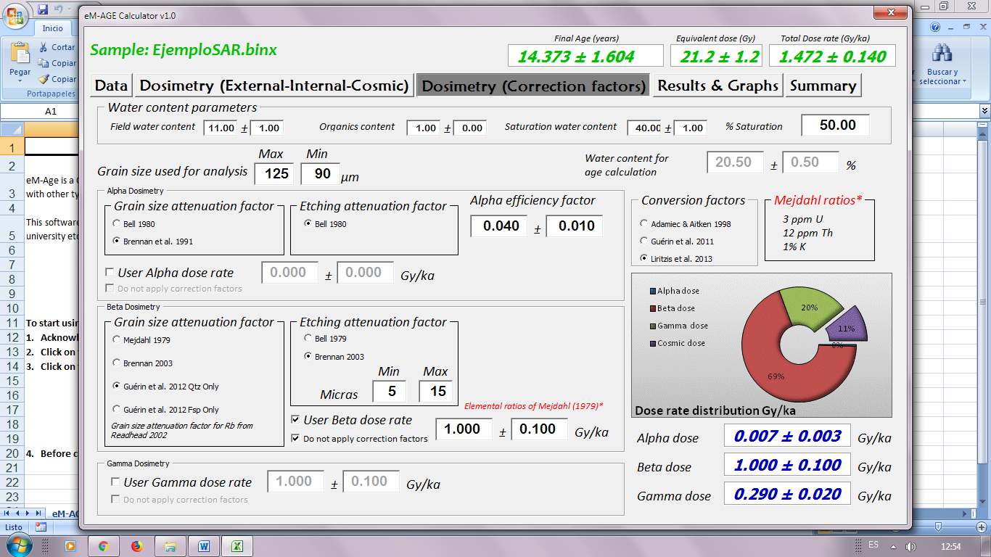

Figure 17

* + 1. **Water content parameters**

This section contains different labels to input your data: *Field water content*, *Organics content*, *Saturation water content* and % Saturation (Fig. 18). The attenuation factors of 1.49, 1.25 and 1.14 (α, β and γ respectively) from Aitken and Xie (1990) and Zimmerman (1971) are used. Dose rates are attenuated using the equation of Aitken and Xie (1990) and uncertainties are propagated in quadrature.



Figure 18

*Field water content* (text field, optional)

Water content of the sample when sampled (as-found). It will not be used for calculation.

*Organics content*

Percentage of organic matter present in the sediment (as-found). The % will be added to the total percentage of water used in the calculus.

*Saturation water content*

Maximum percentage of water that can be present in the sediment. The maximum water content is defined by:

((Weight water saturated sediment – Weight dry sediment) / Weight dry sediment) * 100

*% Saturation*

Percentage of porous filled with water in the sediment. It will give the percentage of the maximum saturation water content used for the calculation.

*Water content for age calculation*

Final percentage of water that will be used for age calculation and corrections. It corresponds to the percentage (input by *% Saturation*) of the *Saturation water content* (Fig. 19).



Figure 19

*Grain size used for analysis*

Dose rates must be corrected for grain-size attenuation effects and a maximum and minimum grain size in μm is required for the calculations (Fig. 20).



Figure 20

Each of the grain size attenuation datasets has been fitted with a smoothed spline function in *RStudio*, and datasets have been generated over the grain size range 1-1000 μm (Durcan *et al*., 2015). The attenuation factor is calculated from the minimum and maximum grain size by taking the mean as the grain size attenuation or absorption factor.

The factors and associated uncertainties are determined for the mean value and associated standard deviations corresponding to a grain size range (e.g., 150 – 250 μm). Similarly, the chemical etching attenuation factors are calculated with 1 μm resolution to correct dose rates for the effects of etching of depths 1-30 μm (worksheet 9-10; Durcan *et al*. 2015).

* + 1. **Alpha dosimetry**

In this frame the user can select the grain size attenuation factors for the alpha dose rate (Fig. 21). The attenuation factor from Bell (1980) will be used for etching.



Figure 21

*Alpha efficiency factor*

This parameter, also called a-value (Aitken and Bowman, 1975), and can be considered as the ratio of luminescence per unit of alpha track length to the luminescence per unit of absorbed beta dose (Aitken, 1985b). The user should input this value as appropriate.

Additionally, the user can introduce the alpha dose rate if it is known by selecting the *“User alpha dose rate”* checkbox. The value input will be corrected by the *alpha efficiency factor* and the different attenuation factors choose, using for it an average attenuation factor calculated assuming the elemental ratios of Mejdahl (1979) (3 ppm U, 12 ppm Th, 1% K2O, Fig. 22). There exists the possibility to introduce a corrected alpha dose rate by selecting the *“Do not apply correction factors”* checkbox.



Figure 22

* + 1. **Beta dosimetry**

Like the alpha dosimetry, the user can choose between different grain size and etching attenuation factors (Fig. 23) for the beta dose rate. For the etching attenuation factor , it is possible to define the minimum and maximum etch depth of the grains (in μm) and the type of calculation carried out, by U, Th and K values independently or by a mean average from the proportional value (see above into the section **Dosimetry (External-Internal-Cosmic)** tab).

The user can select the secondary beta etch attenuation factors of either Bell (1979) or Brennan (2003) for etching (Fig. 23). These datasets have been fitted with a smoothing spline function (Ripley, 2013) over a range of 1-30 mm in RStudio (Durcan et al., 2015). The dataset of Readhead (2002a,b) are used to attenuate the beta dose rate from Rb.



Figure 23

Similarly, the user can introduce a beta dose rate if it is known by selecting the *“User beta dose rate”* checkbox. The value input will be corrected by the different attenuation factors choose, using for it an attenuation factor calculated assuming the elemental ratios of Mejdahl (1979) (3 ppm U, 12 ppm Th, 1% K2O). There is the option to input a corrected beta dose rate by selecting the *“Do not apply correction factors”* checkbox.

* + 1. **Gamma Dosimetry**

The gamma dosimetry will be attenuated by the water content and burial depth if*“Use shallow depth correction”* is selected (see section 2.3.3). In this last case, a weighted average scaling factor computed by Aitken (1985a) is applied (Fig. 24).

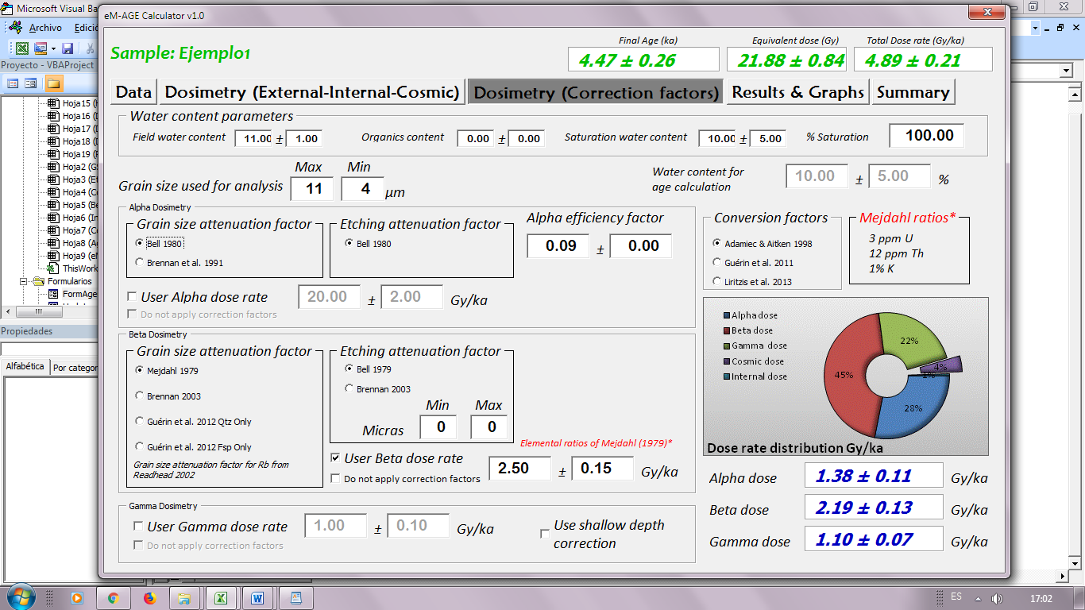

Figure 24

As well as the alpha and beta dosimetry, the user can introduce a gamma dose rate if it is known by selecting the *“User gamma dose rate”* checkbox. There is the option to input a corrected gamma dose rate by selecting the *“Do not apply correction factors”* checkbox. This may be relevant for those who wish to input field gamma spectrometry data for example.

If the depth is ≤ 30 cm, the gamma dose rate can be corrected using the scaling factors of Aitken (1985a) by selecting *“Use shallow depth correction”* checkbox.

* + 1. Graphs

In the lower right-hand corner of this tab, the program shows the values from the different dose rate components (α, β and γ doses in blue) and a graphical representation of these values (in percentage, Fig. 25). Also, the calculated cosmic dose rate (see the separated portion in the graph in Fig. 25) and internal dose rate are shown. Values are refreshed automatically each time an attenuation factor is changed.

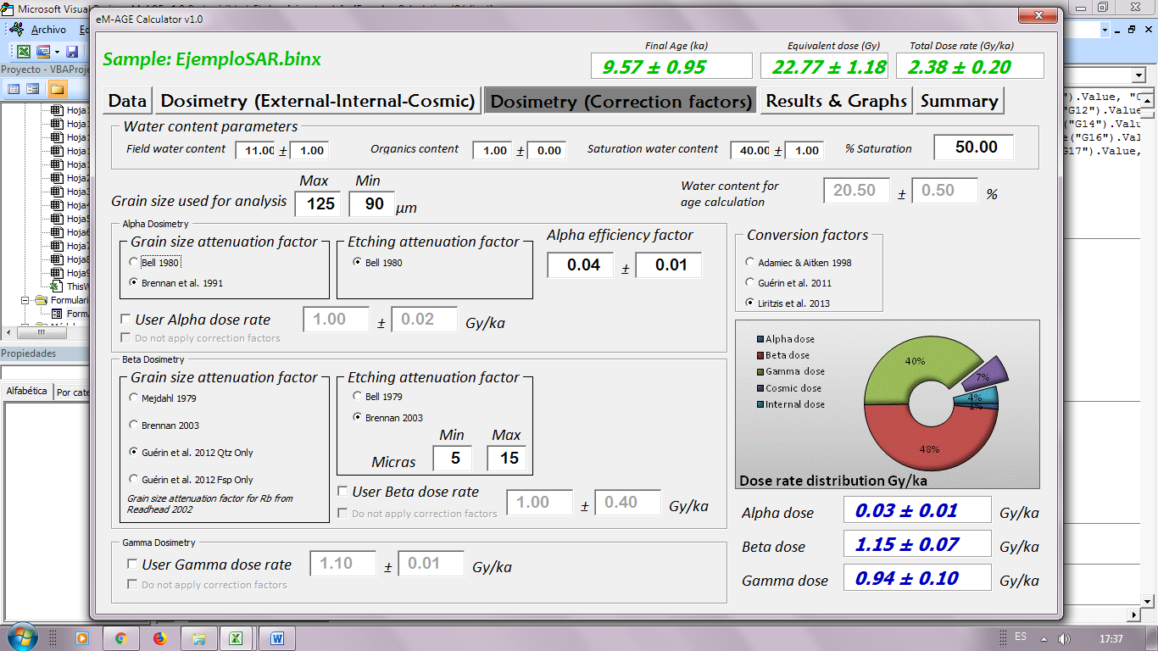

Figure 25

* 1. **“Results & Graphs”** Tab

The **Results & Graphs** tab includes graphical presentation, statistical data and age models such as the common and central age models (Galbraith *et al*., 1999; Galbraith and Roberts, 2012).

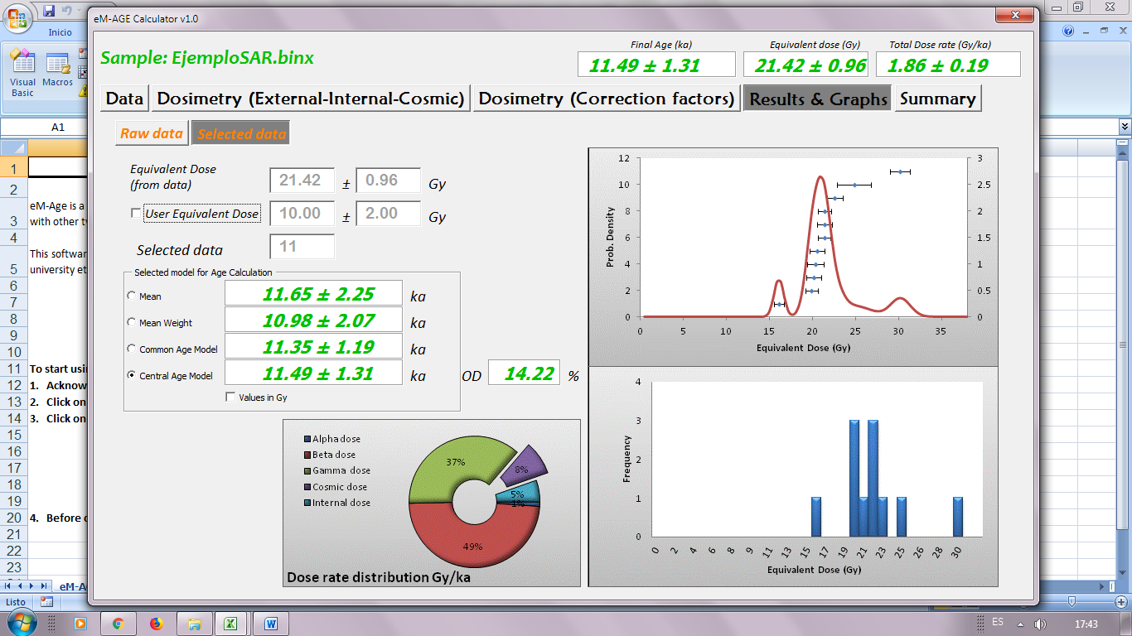

Figure 26

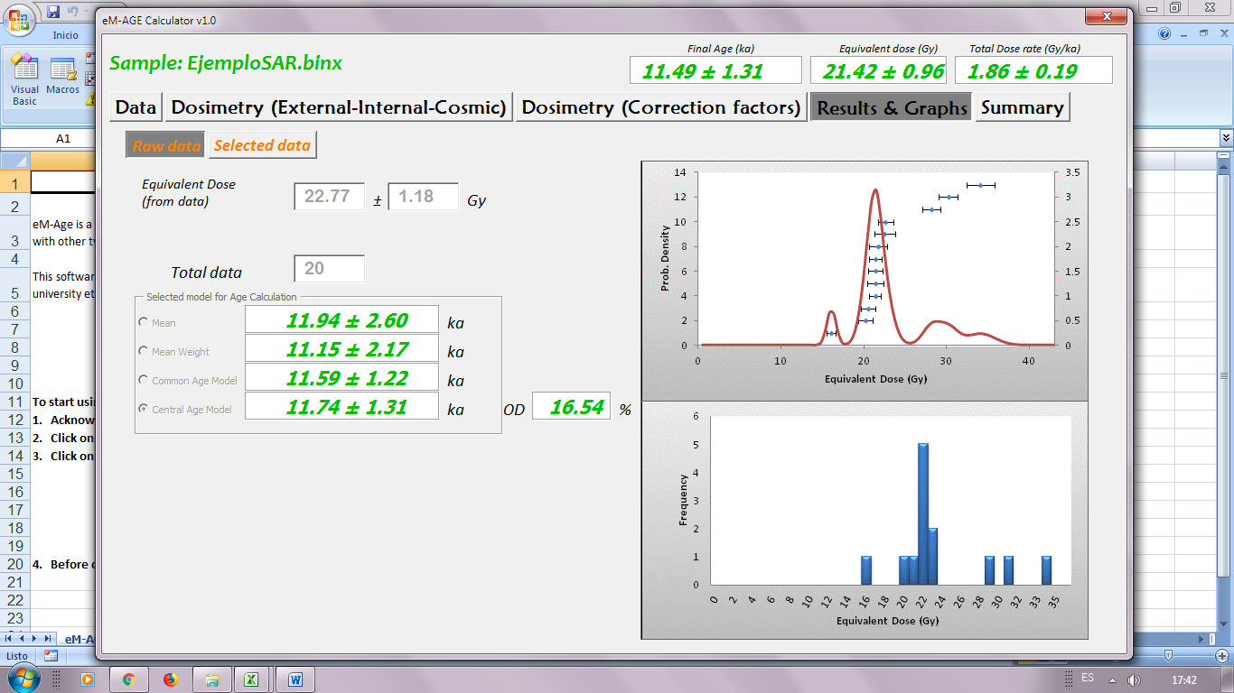

Figure 27

A summary of the final age calculation and graphical presentations of selected (Fig. 26) and total data (**Raw data,** Fig. 27) is shown in this tab.

In this tab, some relevant results and graphs of distribution of equivalent doses (Probability density and histogram) are showed. Also a graph with the different dose rate components (α, β, γ, internal and cosmic doses) is presented.

*Equivalent dose* (from data)

Show the equivalent dose calculated from the selected data in the **“Data”** tab.

*Selected data*

Show the number of selected data into the table of **“Data”** tab (Fig. 28).

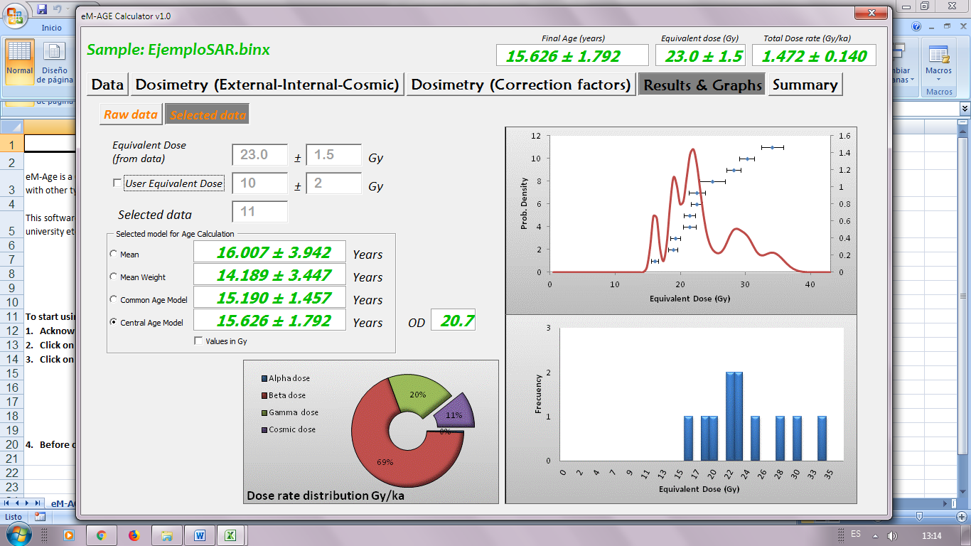

Figure 28

If the equivalent dose data from an Analyst file is used, the probability density graph and the corresponding histogram are showed (both the total data loaded from the file in the tab **“Raw Data”** and the selected by the user in the tab **“Selected data”**).

If *“User Equivalent dose”* checkbox is selected, the probability density and histogram plots will not be shown. The possibility to choose an age model will also be disabled.

* + 1. **Selected model for Age Calculation**

The user can compare and select the different equivalent doses (or final age) calculated from the data loaded from the Analyst file. eM-Age offers four possibilities: Mean, Mean weight, Common Age Model and Central Age Model.

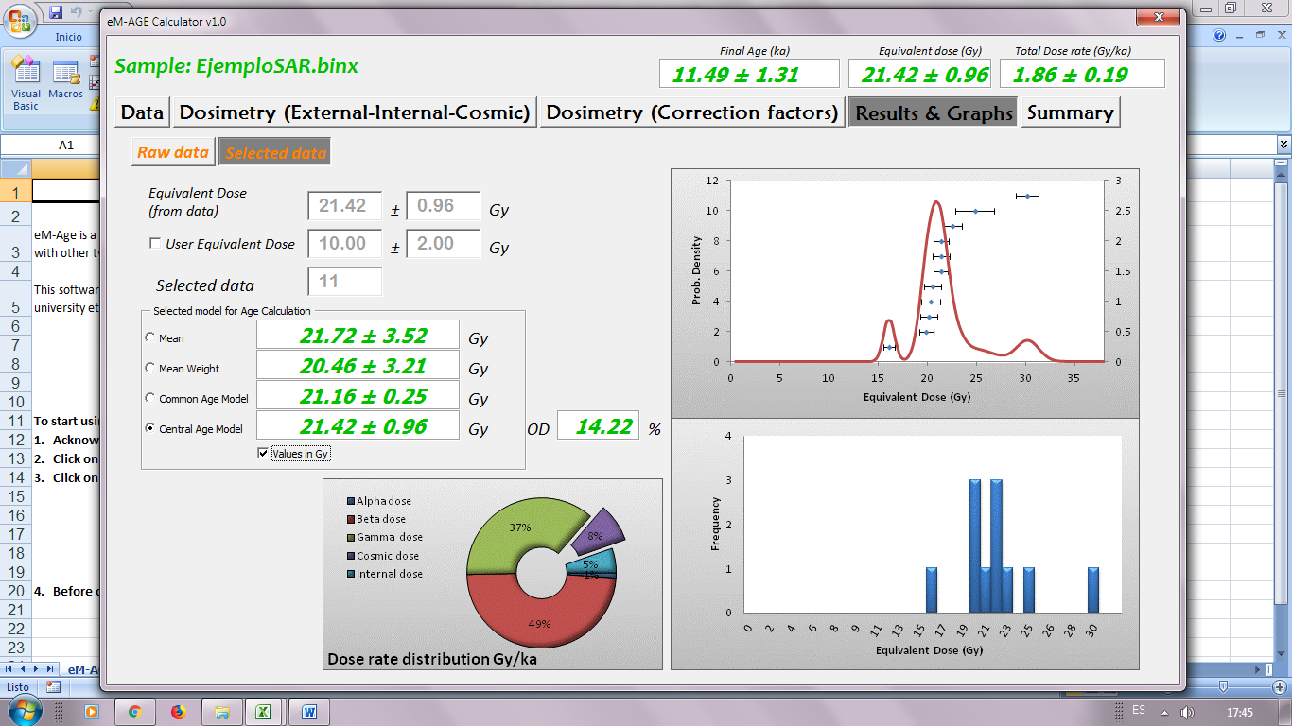

For a detailed explanation of these models, see Analyst Manual v.4.57 (Duller, 2018; p. 51).

* + 1. Graphs

Some relevant graphs of distribution of equivalent doses (Probability density and histogram, Fig. 29) are shown. Also a graph with the different dose rate components (α, β, γ, internal and cosmic doses) is presented. In addition, into the tab“**Raw Data**”the user can compare the graphs resulting from the total data loaded and the data selected by the user.



Figure 29

* 1. **“Summary”** tab

In this tab it is summarized the parameters used in the luminescence age calculations (Fig. 30).

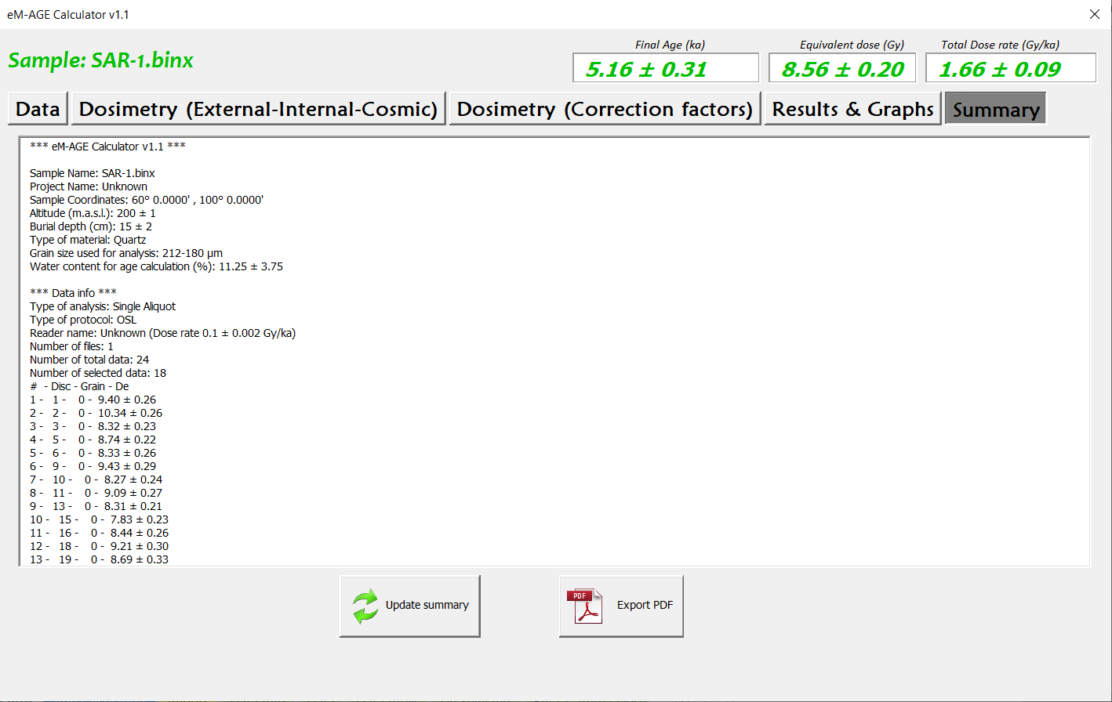

Figure 30

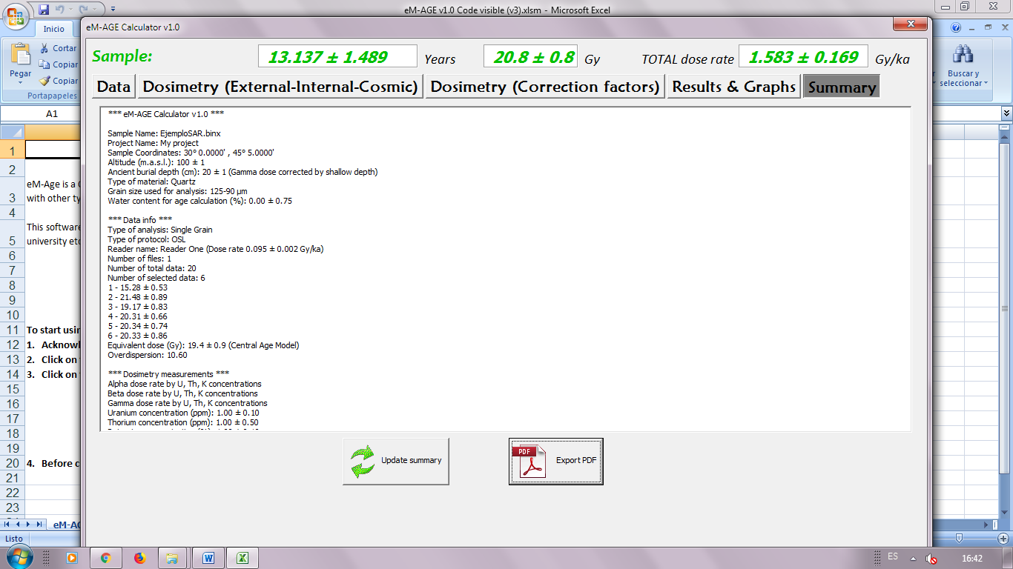

Update summary

Update the data showed in the summary.

Export PDF

This button enables to export the data from the summary showed in PDF format as shown in Fig. 31, as well as the statistical graphs displayed in the **“Results & Graphs”** tab. The summary includes general information of the sample (e.g. name, project, protocol used), the equivalent dose used for calculation (with a list of the individual equivalent doses from the data selected), the used variables (e.g. water content, grain size, altitude, coordinates, etc.), calculated values (e.g. dose rates of the different sources, final age, graphs) and the references used in whole the process.

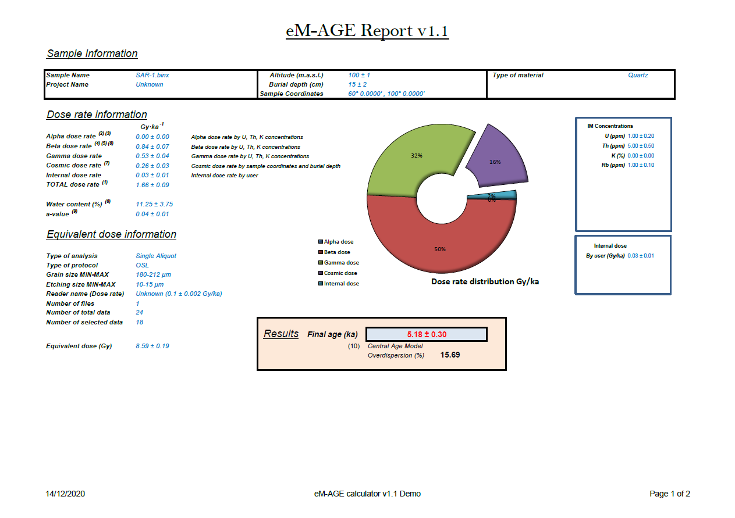Figure

The file generated will be saved as *“Sample name”* Summary.pdf

Additionally, the program allows the user to copy and paste the last report generated selecting the worksheet Report in the main Excel window (closing the macro).

1. Save Results

It is important before closing the main Excel Window (not the macro window) to save your inputs and results.

Also, during the process of calculation the program generates (in the folder where it is located) a number of files with .gif format that can be used in other programs or reports made by the user.

1. References

Adamiec, G., Aitken, M.J., 1998. Dose-rate conversion factors: update. Anc. TL 16, 37-46.

Aitken, M.J., 1985a. Thermoluminescence Dating. Academic Press, New York. 351 p.

Aitken, M.J., 1985b. Alpha particle effectiveness: numerical relationship between systems. Anc. TL 3, 22-25.

Aitken, M.J., Xie, J., 1990. Moisture correction for annual gamma dose. Anc. TL 8, 6-9.

Aitken, M.J., 1998. An Introduction to Optical Dating: the Dating of Quaternary Sediments by the Use of Photon-stimulated Luminescence. Oxford Science Publications, Oxford. 267 p.

Aitken, M.J., Bowman, S.G.E., 1975. Thermoluminescent dating: assessment of alpha particle contribution. Archaeometry 17, 132-138.

Bell, W.T., 1979. Attenuation factors for the absorbed radiation dose in quartz inclusions for thermoluminescence dating. Anc. TL 8, 1-12.

Bell, W.T., 1980. Alpha attenuation in Quartz grains for Thermoluminescence Dating. Anc. TL 12, 4-8.

Brennan, B.J., Lyons, R.G., Phillips, S.W., 1991. Attenuation of alpha particle track dose for spherical grains. Int. J. Radiat. Appl. Instrum. Part D. Nucl. Tracks Radiat. Meas. 18, 249-253.

Brennan, B.J., 2003. Beta doses to spherical grains. Radiat. Meas. 37, 299-303.

Duller, G.A.T., 2018. Enhancing Analyst by integrating the R package ‘Luminescence’. Anc. TL 36(2), 1-6.

Durcan, J. A., King, G. E., Duller, G. A. T., 2015. DRAC: An online Dose Rate and Age Calculator. Quat. Geochronol. 28, 54-61.

Duller, G. A. D., 2018. Analyst v4.57-User Manual. Aberystwyth Luminescence Research Laboratory, Aberystwyth University. [http:/users.aber.ac.uk/ggd](http://users.aber.ac.uk/ggd)

Galbraith, R.F., Roberts, R.G., Laslett, G.M., Yoshida, H. and Olley, J.M., 1999. Optical dating of single and multiple grains of quartz from Jinmium rock shelter, northern Australia: Part I, Experimental design and statistical models. Archaeometry 41, 339-364.

Galbraith, R.F., Roberts, R.G., 2012. Statistical aspects of equivalent dose and error calculation and display in OSL dating: An overview and some recommendations. Quaternary Geochronology 11: 1-27.

Guérin, G., Mercier, N., Adamiec, G., 2011. Dose-rate conversion factors: update. Anc. TL 29, 5-8.

Guérin, G., Mercier, N., Nathan, R., Adamiec, G., Lefrais, Y., 2012. On the use of infinite matrix assumption and associeted concepts: A critical review. Radiat. Meas. 47(9), 778-785.

Liritzis, I., Stamoulis, K., Papachristodoulou, C., Ioannides, K., 2013. A re-evaluation of radiation dose-rate conversion factors. Mediterr. Archaeol. Archaeom. 13, 1-15.

Mejdahl, V., 1979. Thermoluminescence dating: beta-dose attenuation in quartz grains. Archaeometry 21, 61-72.

Mejdahl, V., 1987. Internal radioactivity in quartz and feldspar grains. Anc. TL 5, 10-17.

Prescott, J.R., Hutton, J.T., 1988. Cosmic ray and gamma ray dosimetry for TL and ESR. Nucl. Tracks Radiat. Meas. 14, 223-227.

Prescott, J.R., Hutton, J.T., 1994. Cosmic ray contributions to dose rates for luminescence and ESR dating: large depths and long-term time variations. Radiat. Meas. 23, 497-500.

Readhead, M.L., 2002a. Absorbed dose fraction for 87Rb beta particles. Anc. TL 20, 25-29.

Readhead, M.L., 2002b. Appendum to “Absorbed dose fraction for 87Rb beta particles”. Anc. TL 20, 47.

Ripley, B., 2013. Pspline: Penalized Smoothing Splines. R Package Version 1.0-16. S original by Jim Ramsey. <http://CRAN.R-project.org/package=pspline>.

Zimmerman, D.W., 1971. Thermoluminescence dating using ﬁne grains from pottery. Archaeometry 13, 29-52.